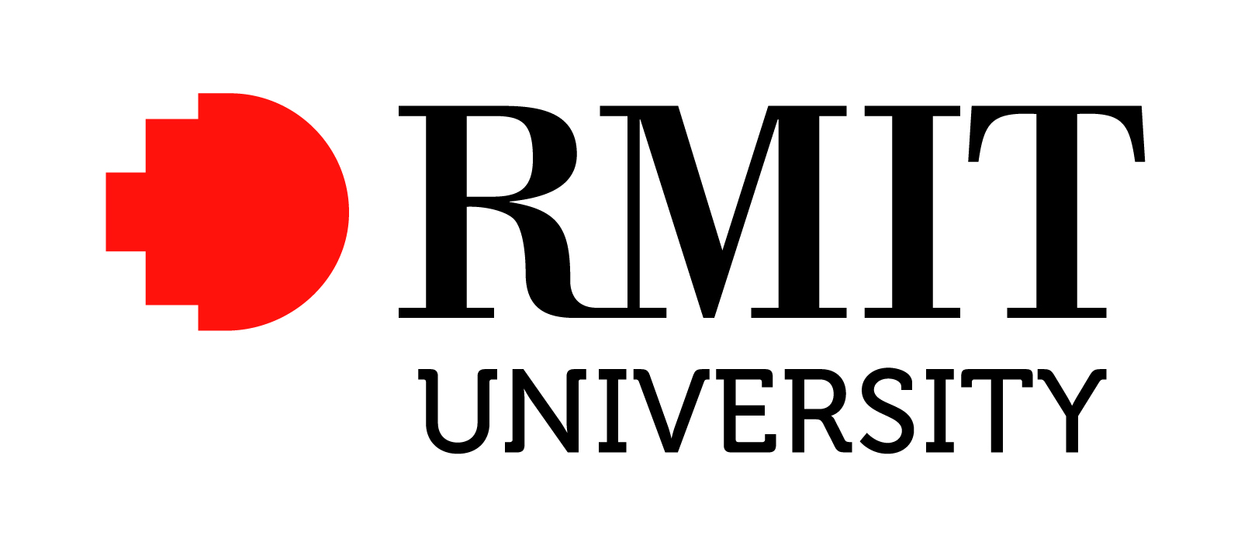

Position Description – Research Fellow (Biophysics and Bioengineering)

Position Details
Position Title: Research Fellow (Biophysics and Bioengineering)

Position Number: NEW

Portfolio: College of Science, Engineering and Health

School/Group: School of Aerospace Mechanical and Manufacturing Engineering and Health Innovations Research Institute

Campus Location: Based at the City campus, but may be required to work and/or be based at other campuses of the University.

Classification: Academic B
Salary Schedule: http://www.rmit.edu.au/browse;ID=ewhtlt73t01

Employment Type: Fixed Term-Research
Note: See Reasons for fixed term appointments guideline for explanation of fixed term categories

Time Fraction: 1.0 FTE

RMIT University
RMIT is a global university of technology and design, focused on creating solutions that transform the future for the benefit of people and their environments. We are global in attitude, action and presence; urban in orientation and creativity; and connected through active partnerships with professions, industries and organisations.
RMIT University enjoys an international reputation for excellence in professional and practical educational programs and high quality outcome-oriented research.
One of Australia’s original educational institutions founded in 1887, RMIT is now the nation’s largest tertiary institution. The University offers an extensive range of postgraduate, undergraduate and vocational programs.
RMIT has three Melbourne campuses – in the central business district and in Brunswick and Bundoora in the city’s northern suburbs – and campuses in Hanoi and Ho Chi Minh City in Vietnam. With significant partnerships in Hong Kong, China, Malaysia and Singapore, RMIT has a strong educational presence in the Asia-Pacific region. The University’s total student population of 74,000 includes 30,000 international students (onshore and offshore).
RMIT is a leader in technology, design, global business, communication, global communities, health solutions and urban sustainable futures, and is ranked in the top 100 universities in the world for engineering and technology in the 2010 QS World University Rankings. For further information refer to www.rmit.edu.au

Health Innovations Research Institute (HIRi)

“Translating fundamental science into better health outcomes”

RMIT HIRi takes an integrated approach to address key health issues facing the Australian community in the 21st century through research programmes focussing on understanding how the human body functions at a molecular and cellular level. This knowledge will inform innovative therapeutic strategies to target disease states.

The primary goal of the institute is to translate basic science discoveries into effective, safe therapeutic outcomes.

A Research Institute
The RMIT mission is “to create and disseminate knowledge to meet the needs of industry and community”. The Health Innovations Research Institute is a new RMIT initiative that seeks to better connect the diverse communities around health enterprise to more effectively address the changing needs of biomedical research and society. It capitalises on existing institutional strengths to build increased research and translation capacity in identified areas of socio-economic health burden. These include cardiovascular diseases, insulin resistance and diabetes, obesity, arthritis, mental health disease and stroke.

The four research programs that bring together a growing team of over 100 researchers and their collaborators are:

- Ion channels and transporters as therapeutic targets
- Metabolism, exercise and disease
- Traditional and complementary medicine
- Biophysics and bioengineering

HIRi will also provide a platform for state-of-the-art infrastructure and technologies to enable virtual R&D capabilities to be shared with research and industry partners.

Further details regarding the Institute can be found at: http://www.rmit.edu.au/research/institutes/healthinnovations

College/School
College of Science, Engineering & Health

The College comprises 10 Schools delivering a broad range of programs in Science, Engineering and Health at Apprenticeship, Certificate, Bachelor, Masters and PhD levels. Many programs articulate between TAFE and Higher Education, creating pathways for further study.
There is a vibrant research community attracting funding from a range of government and industry sources. The College has an annual budget of approximately $209 million and employs over 1,000 staff providing on and offshore programs to approximately 20,000 students. For further information refer to www.rmit.edu.au/seh

School of Aerospace, Mechanical and Manufacturing Engineering

The School of Aerospace, Mechanical and Manufacturing Engineering is one of the largest and progressive engineering schools in Australia.

The School has an establishment of over 100 staff and 2000 students covering the disciplines of Aerospace & Aviation, Mechanical & Automotive Engineering and Manufacturing & Materials Engineering. The School is recognised nationally for excellence in industry focused education and applied research, with a total profile of around 1800 equivalent full-time students (EFTSL) across undergraduate and postgraduate programs. The School has modern facilities for students and staff on attractive and spacious campuses at Bundoora and the City. The 1st and 2nd years of all undergraduate programs run at the City campus while the remaining years and research students are located at the Bundoora campus. The School’s resources include an industrial wind tunnel capable of testing full-scale vehicles, specialist aerodynamics laboratories, a renewable energy & energy conservation park, composites and materials testing laboratories, advanced manufacturing systems laboratory, engine testing laboratories, dynamics and NVH laboratory, metrology laboratory and a range of advanced CAE laboratories. The School is an active member of the CRC for Advanced Automotive Technologies, CRC for Advanced Composites Structures, National CRC for Advanced Manufacturing and Defence Materials Technology Centre (DMTC) with over 165 PhD research students working across the three disciplines of the School. The research focus areas in the discipline of Aerospace and Aviation Engineering include advanced composite structures, unmanned aerial systems (UAS), aerodynamics and systems dynamics, aerospace propulsion and low emission technologies for aviation.

Details relating to the School can be found at: http://www.rmit.edu.au/aeromecheng

Position Summary
This position is for a Postdoctoral Research Fellow to work on the developing collaboration with the Institute for Biomaterials Engineering at Imperial College London. The Research Fellow will be required to provide high level theoretical computing expertise in developing new methodologies and applying them to study the structure, properties and performance of novel classes of biologically relevant nanomaterials under various conditions. The Research Fellow is expected to work closely with the collaborating team at Imperial College London where the experimental component of the work will be performed. The Research Fellow will provide a key research role in performing calculations and providing theoretical guidance for the experimental team as well as RMIT project team members, including postgraduate and undergraduate research students. The Research Fellow will prepare publications, project reports and contribute to patents in collaboration with other team members. The Research Fellow will participate in the day-to-day operation of other research projects in the area of materials theory and simulation, some involving industry collaboration and/or postgraduate research students, as well as will help generating new research projects and proposals in collaboration with the group Leader and external partners. The Research Fellow will participate in undergraduate programs relevant to research in the Materials Modelling and Simulation group aiming to attract Honours and postgraduate research students to the group.

Reporting Line
Reports to: Prof. Irene Yarovsky, Program Leader - Biophysics and Bioengineering, Health Innovations Research Institute

Direct reports: Nil

Organisational Accountabilities
RMIT University is committed to the health, safety and wellbeing of its staff. RMIT and its staff must comply with a range of statutory requirements, including equal opportunity, occupational health and safety, privacy and trade practice. RMIT also expects staff to comply with its policy and procedures, which relate to statutory requirements and our ways of working.

Appointees are accountable for completing training on these matters and ensuring their knowledge, and the knowledge of their staff, is up to date.

Key Accountabilities
The appointee is responsible for conducting tasks under supervision of the designated Project Leader (Prof. Yarovsky), and for working both as a member of a team and independently. Tasks will include:

- Contribute to research and development activities in the relevant HIRi programs
- Generate publications in high-quality journals and ensure steady publication outcomes
- Provide support to supervision of honours and higher degree research students
- Participate in and initiate new R&D collaborations via preparation of project proposals
- Organize, attend and/or support meetings, forums, seminars and such like associated with the work of the Institute and School, as well as being involved in other related meetings in the field as required
- Contribute to related tasks as specified by the Project/Program Leader
- Liaise with industry and academia as directed and build up new collaboration opportunities
- Undertake teaching duties up to 10% of fulltime load.
- Other duties as directed by the Head of School.

Key Selection Criteria
- Good research track record on a national and international level in the area of theoretical chemistry, physics or materials science with experience in multiscale modelling of materials evidenced by high-quality publications and/or research grants
- The demonstrated ability to participate in multiple research programs and to develop ideas into proposals
- Proven experience in working with research and/or innovation teams responsible for conducting research activities and projects, within an interdisciplinary environment. Demonstrated independence in carrying out research would be useful.
- Excellent interpersonal skills, including the ability to consult, interact and collaborate effectively within and external to the organisation, with the ability to supervise postgraduate research students
- Proven project-management skills from planning through to implementation, including the ability to deliver against targets and timelines
- Proven ability to work co-operatively as a team-member, managing interdisciplinary research and innovation programs in collaboration with internal and external stakeholders

Qualifications
PhD in Chemistry, Physics, Materials science or related discipline

Endorsed: | Signature:  Name: Prof. David J. Adams  Title: Director, HIRi  Date: | Endorsed: | Signature:  Name: Prof. Aleksandar Subic  Title: Dean of Engineering and Head of School, Aerospace, Mechanical and Manufacturing Engineering  Date: 9 Jan 2013
Approved: | Signature:  Name: Prof Peter Coloe  Title: PVC Science, Engineering & Health  Date:

