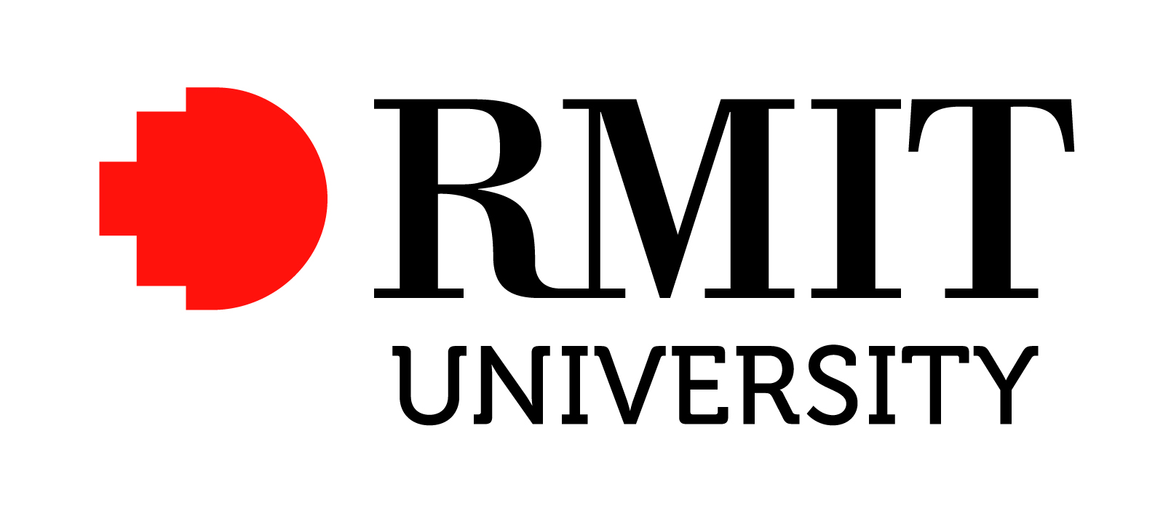

Position Description – Senior Research Fellow

Position Details
Position Title: Senior Research Fellow

Position Number: NEW

College: RMIT University three Academic Colleges are:
Business, Design & Social Context, Science, Engineering & Health

School/Group: The School appropriate to the successful applicant’s research specialisation

Campus Location: Base campus will be dependent on School requirements, but may be required to work and/or be based at other campuses of the University. Main campuses are located in the City, at Bundoora and at Brunswick.

Classification: Academic Level C
Salary Schedule: http://www.rmit.edu.au/browse;ID=ewhtlt73t01

Employment Type: Fixed Term – 4 Years

Time Fraction: 1.0 FTE

RMIT University
RMIT is a global university of technology and design, focused on creating solutions that transform the future for the benefit of people and their environments. We are global in attitude, action and presence; urban in orientation and creativity; and connected through active partnerships with professions, industries and organisations.
RMIT University enjoys an international reputation for excellence in professional and practical educational programs and high quality outcome-oriented research.
One of Australia’s original educational institutions founded in 1887, RMIT is now the nation’s largest tertiary institution. The University offers an extensive range of postgraduate, undergraduate and vocational programs
RMIT has three Melbourne campuses – in the central business district and in Brunswick and Bundoora in the city’s northern suburbs - campuses in Hanoi and Ho Chi Minh City in Vietnam and a site in Barcelona, Spain. With significant partnerships in Hong Kong, China, Indonesia, Malaysia and Singapore, RMIT has a strong educational presence in the Asia-Pacific region. The University’s total student population of 82,000 includes 30,000 international students (onshore and offshore).
RMIT is a leader in technology, design, global business, communication, global communities, health solutions and urban sustainable futures. It is ranked in the top 150 universities in the world for engineering, computer science and information systems, economics, communication and media studies, accounting and finance and education in the 2013 QS World University Rankings and 10th in Australia.
www.rmit.edu.au

Research at RMIT University
RMIT research and research training is global, partnered and making a difference.
The University aspires to:
- make a significant contribution to knowledge in our areas of specialisation and identify and develop innovative solutions to problems affecting urban communities around the world; and
- work with internationally recognised partners to build synergies that ensure our research is relevant and contributes to solving problems affecting urban communities around the world.

Research at RMIT is particularly focused in the following areas:
- Designing the Future
- Smart Technology Solutions
- Improving Health & Lifestyle
- Sustainability & Climate Change Challenges
- The Future of Cities

Research staff at RMIT University are based in Schools and our Research Institutes and Centres provide focus and support for outcome-related multi-disciplinary research that is undertaken in collaboration with leading organisations and industry partners. These partners ensure our research outcomes make a difference. The Research Institutes, in combination with Research Centres and Research Groups, drive significant and sustainable growth in RMIT’s research capacity and performance and through enhanced collaboration across RMIT:
- deliver strong research outcomes in areas of research excellence and scale;
- support researchers at all levels from Early Career Researchers to Senior Academics to continue excelling;
- support and encourage RMIT’s emerging researchers to grow their profiles and performance;
- underpin RMIT’s research reputation and profile and build sustainable research growth through external funding.

Find out more about research at RMIT University at http://www.rmit.edu.au/research/

RMIT University’s three Academic Colleges

The College of Business has established a reputation for excellence in business and management education, providing high quality industry responsive programs relevant to the national and global marketplace.
Find out more about research in the College of Business at http://www.rmit.edu.au/bus

The College of Design & Social Context (DSC) encompasses RMIT’s art, communication, design, education, humanities, property and social science discipline areas.
Find out more about research in the College of Design & Social Context at http://www.rmit.edu.au/dsc/research

The College of Science, Engineering and Health (SEH) incorporates the fields of Science, Engineering, IT and Health and Medical Sciences.
Find out more about research in the College of Science, Engineering and Health http://www.rmit.edu.au/seh

Position Summary
The Senior Research Fellow will be located within a School environment and work with research teams and partnerships in the School and Research Institutes. The Senior Research Fellow is required to undertake research activities in line with the University’s research strategy that emphasises relevant and applied business research. The position will make independent and original contributions to research, which have a significant impact in the area of their specialisation as well as be acknowledged at an international level as being influential in expanding the knowledge of their relevant discipline.

The Senior Research Fellow role is primarily to develop, engage in and lead high quality research projects that are aligned with the University’s research focus areas. The Senior Research Fellow will have an important research leadership role in embedding their research expertise into the life of the School and will be required to develop high-quality, productivity-driven research networks across RMIT and with local, national and global, internal and external partners. Senior Research Fellows will be expected to engage in high quality research projects, to achieve success in attracting research funding and to produce high quality outputs. The position may undertake limited teaching duties.

Reporting Line
Reports to: A School reporting line through to the Head of School

Organisational Accountabilities
RMIT University is committed to the health, safety and wellbeing of its staff. RMIT and its staff must comply with a range of statutory requirements, including equal opportunity, occupational health and safety, privacy and trade practice. RMIT also expects staff to comply with its policy and procedures, which relate to statutory requirements and our ways of working.

Appointees are accountable for completing training on these matters and ensuring their knowledge, and the knowledge of their staff, is up to date.

Key Accountabilities
- Lead and manage high quality research involving design and development of projects aligned to RMIT’s research focus areas.
- Grow RMIT’s external research funding and profile by identifying, initiating and preparing funding applications for Australian competitive funding as well as client-oriented and international research income.
- Extend the research performance and reputation of the discipline through effective engagement with industry partners and other organisations. Use these relationships to develop collaborative projects with stakeholders both inside and outside RMIT and from the local to the global environments.
- Successfully manage research activities and milestones by ensuring progress reviews for RMIT and industry partners and are completed to the required level within agreed timeframes and budget restraints.
- Regularly disseminate research outcomes and communicate with other team members, clients and the broader research community internal and external to RMIT University.
- Contribute to the development and application of plans to enhance delivery of research outcomes and performance within the School and across the University. Develop and build collegiality through active interactions and participation in events, forums, workshops in the School, College and broader research community of the University.
- Undertake administrative duties as required.
- To assume joint responsibility for career development by actively participating in various activities and producing a jointly agreed development plan.
- Undertake supervision of research students and may undertake limited teaching duties.

Key Selection Criteria
- Demonstrated ability to conduct high quality research.
- Recognised and established track record of research publications or equivalent at national and international level.
- Demonstrated capacity to attract external research funding, conduct complex collaborative projects and to liaise with the public, government bodies and community sectors in research matters.
- Ability to clearly communicate research approaches, concepts and outcomes.
- Proficient in consulting, interacting and collaborating effectively within and external to the organization, with the ability to move across academic, government and industry constituencies and to negotiate agreed outcomes and targets, partnering with key stakeholders in order to achieve agreed goals.
- Demonstrated experience in leading collaborative research projects, preferably within an interdisciplinary environment.
- Demonstrated experience in project management from planning through to implementation including the ability to deliver against targets timelines and budget restraints.
- Ability to provide leadership in research, including research training and supervision.

Qualifications
Mandatory: PhD in a related field.

Endorsed  Signature:  Name: Prof David Adams  Title: Acting DVC Research & Innovation  & Vice President  Date: | Approved  Signature:  Name: Prof Margaret Gardner  Title: Vice-Chancellor & President  Date:

