HRF2 EMPLOYMENT APPLICATION 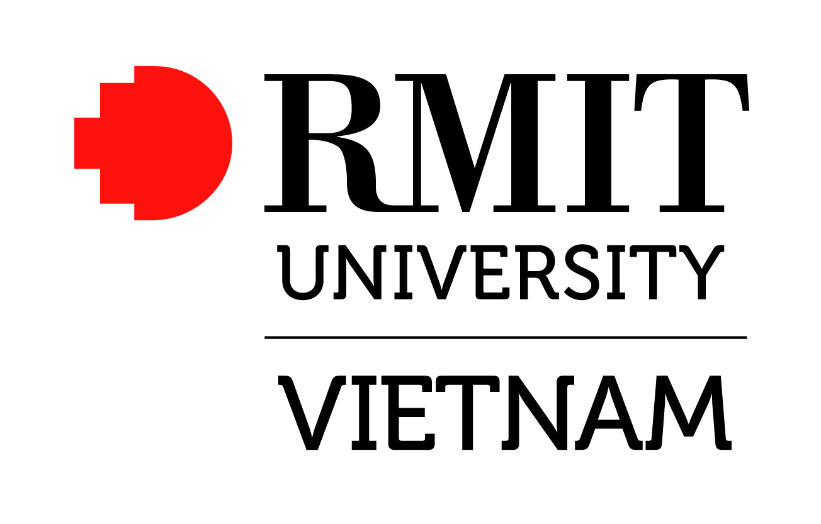

1 Your application
For your application to be considered, RMIT Vietnam requires that you provide:
- This completed Application Sheet including Applicant Declaration (see below)
- Your curriculum vitae
- Copy of qualifications
- Names of three referees and their contact details (Note: These referees will not be contacted without prior notification to you)

2 Job application form
Job Ref |  |  |  | Position Title
Title |  |  |  | Family Name |  |  |  |  | First Name
Full name as shown in your passport:
Residential Address |  |  |  |  |  |  |  |  | City
Country |  |  |  |  |  |  | Telephone number
Email
Citizenship
Where did you see this job advertised?
Additional Information
The following information is gathered on a voluntary basis (all information is kept in strict confidence):
  - Do you wish to identify yourself as a person with a disability (please tick):
- Language spoken at home: (If other than English)
- Country of Birth:
3 Applicant Declaration
“I consent to the collection, storage and disclosure of information concerning any acts of record falsification or other irregular acts in relation to myself. I confirm that all information contained in my application is true and correct”.
Signed:
Print name: |  |  |  |  |  |  |  | Date:
If you are emailing your application, please include this statement in your email/cover letter to indicate your consent.
4 Address applications to
Send Applications by email to: employment@rmit.edu.vn

