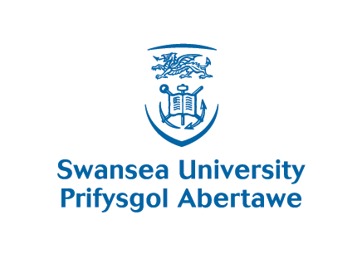
For COAH PGTM Office Use Only:
Decision: | Application Status:
Amount: | Place Accepted:
Date of Receipt: | Deposit Paid:
Initials:

2014 – 2015 Dylan Thomas Scholarship Application
Title | Last Name | First Name(s)
D.O.B | E-Mail: | Telephone:
Country: |  | Student ID:
Please Circle the level of course you are applying for:
Postgraduate Taught Masters
Course Name:

How did you hear about the Dylan Thomas Scholarship and Swansea University?
Please provide us with three reasons for choosing/applying to Swansea University:

How will Swansea University benefit from having you on the course (max. 500 words)?

Please explain why you should be awarded a Dylan Thomas Scholarship (max. 1000 words please continue on a separate sheet if required):

If you have been offered scholarships from other universities, please give the name and amount here: |  | Agent Name (if applicable):
- Please attach a transcript detailing your courses and grades.
- Please read Regulations and conditions below.
- The Deadline for scholarship application is 2nd June 2014
- Please return the Application form to: Mrs Anne Doel,
COAH Postgraduate Taught Masters & International Office, Keir Hardie Buidling
Swansea University, Singleton Park, Swansea, SA2 8PP
Telephone: +44 (01792 602005 Email: a.e.doel@swansea.ac.uk Fax: +44 1792 602395

ELIGIBILITY, TERMS AND CONDITIONS
- International Applicants must be from non-EU countries only.

- Dylan Thomas Scholarships will be used to offset tuition fees.

- Applicants are not eligible to hold other Swansea University awards such as bursaries, or home country sponsorship.

- Applicants must be enrolling on the Taught Masters course at Swansea University for the first time in September 2014.

- Awards are available for full-time Postgraduate Taught Masters degree programme only.

- Applicants must have completed an application for a place to study and be holding Swansea University Conditional or Unconditional Firm choice.
- Successful candidates will be informed by the beginning of July 2014; a reduced tuition fee will be levied at enrolment. Candidates must confirm acceptance of their scholarship, accept an offer of a place on a course. International candidates must pay their £2000 deposit.

- The Dylan Thomas Scholarship Committee may use whatever means of assessment it thinks most appropriate in order to determine which candidates are worthy of recommendation for the award of a scholarship.

- Scholarship holders, having accepted an award, are reasonably expected to co-operate in Swansea University recruitment activities and automatically agree to their names and details being released by the College of Arts and Humanities and the International Development Office for marketing purposes.

- If it is deemed necessary for a Scholarship holder to suspend their studies, the scholarship will be held on university account and carried forward to the year of resumption of studies and the candidate will be expected to pay their personal contribution on a pro-rata basis.

- If in the view of the appropriate Head of College, a Scholarship holder’s progress is deemed to be unsatisfactory, the Scholarship may be withdrawn. A Scholarship may also be withdrawn on grounds of failure to comply with any of the conditions attached to the Award. The candidate may be required to repay to the University any award, which has been made, either in whole or in part, as determined by the Committee. If the scholar feels that such a withdrawal is unjustified s/he may appeal in writing to the Head of the College within 15 working days of the date of notification.

- The College of Arts and Humanities reserves the right to make, amend, withdraw, suspend or cancel without notice these and such other Regulations as may be in force from time to time and such decisions shall be final.

