
Position Description – Lecturer

Position Details
Position Title: Lecturer in Aviation

Position Number: 50059011

College: Science, Engineering and Health

School/Group: School of Aerospace, Mechanical and Manufacturing Engineering

Campus Location: Based at the City campus, but may be required to work and/or be based at other campuses of the University.

Classification: Academic Level B
Salary Schedule: http://www.rmit.edu.au/browse;ID=ewhtlt73t01

Employment Type: Continuing

Time Fraction: 1.0

RMIT University
RMIT is a global university of technology and design, focused on creating solutions that transform the future for the benefit of people and their environments. We are global in attitude, action and presence; urban in orientation and creativity; and connected through active partnerships with professions, industries and organisations.
RMIT University enjoys an international reputation for excellence in professional and practical educational programs and high quality outcome-oriented research.
One of Australia’s original educational institutions founded in 1887, RMIT is now the nation’s largest tertiary institution. The University offers an extensive range of postgraduate, undergraduate and vocational programs
RMIT has three Melbourne campuses – in the central business district and in Brunswick and Bundoora in the city’s northern suburbs - campuses in Hanoi and Ho Chi Minh City in Vietnam and a site in Barcelona, Spain. With significant partnerships in Hong Kong, China, Indonesia, Malaysia and Singapore, RMIT has a strong educational presence in the Asia-Pacific region. The University’s total student population of 82,000 includes 30,000 international students (onshore and offshore).
RMIT is a leader in technology, design, global business, communication, global communities, health solutions and urban sustainable futures. It is ranked in the top 150 universities in the world for engineering, computer science and information systems, economics, communication and media studies, accounting and finance and education in the 2013 QS World University Rankings and 10th in Australia.
www.rmit.edu.au

Portfolio/Group
The College comprises 10 Schools delivering a broad range of programs in Science, Engineering and Health at Apprenticeship, Certificate, Bachelor, Masters and PhD levels. Many programs articulate between TAFE and Higher Education, creating pathways for further study.

There is a vibrant research community attracting funding from a range of government and industry sources. The College has an annual budget of approximately $209 million and employs over 1,000 staff providing on and offshore programs to approximately 20,000 students.

School of Aerospace, Mechanical and Manufacturing Engineering
The School of Aerospace, Mechanical and Manufacturing Engineering is one of the largest and progressive engineering schools in Australia.

The School has an establishment of around 130 staff, covering the disciplines of Aerospace & Aviation Engineering, Mechanical & Automotive Engineering and Manufacturing & Materials Engineering. The School is recognised nationally for excellence in industry focused education and applied research, with a total profile of around 2200 equivalent full-time students (EFTSL) across undergraduate and postgraduate programs. This is a research intensive School with significant number of externally funded research projects with industry and other organisations. The School has modern facilities for students and staff on attractive and spacious campuses at Bundoora and the City. The 1st and 2nd years of all undergraduate programs run at the City campus while the remaining years and research students are located at the Bundoora campus. The School’s resources include an industrial wind tunnel capable of testing full-scale vehicles, specialist aerodynamics laboratories, a renewable energy & energy conservation park, composites and materials testing laboratories, advanced manufacturing systems laboratory, engine testing laboratories, dynamics and NVH laboratory, metrology laboratory and a range of advanced CAE laboratories. The School is an active member of the CRC for Advanced Automotive Technologies, CRC for Advanced Composites Structures, Defence Material Technology Centre (DMTC), Wound Management CRC, Advanced Manufacturing CRC and Railway Manufacturing CRC with around 170 PhD research students working across the three disciplines of the School. Also, the School runs significant number of teaching and research programs within the new RMIT Advanced Manufacturing Precinct (AMP) including the Engineering Learning Factory and the new Research Centre for Additive Manufacturing.

Details relating to the School can be found at: http://www.rmit.edu.au/aeromecheng

Position Summary
The Lecturer is expected to make a significant contribution to the teaching and research efforts of the School, in particular in the discipline of Aerospace and Aviation Engineering focusing on air traffic management, aviation safety systems, avionics, and human factors in aviation. This position will be expected to undertake high quality research in the designated fields preferably in collaboration with industry, including supervision of project students and HDR students.
The incumbent will be expected to participate in the academic activities of the School and the College and to pursue a program of professional development consistent with the strategic goals of the School.

Reporting Line
Reports to: Deputy Head of School, Aerospace and Aviation Engineering

Direct reports: Nil

Organisational Accountabilities
RMIT University is committed to the health, safety and well-being of its staff. RMIT and its staff must comply with a range of statutory requirements, including equal opportunity, occupational health and safety, privacy and trade practice. RMIT also expects staff to comply with its policy and procedures, which relate to statutory requirements and our ways of working.

Appointees are accountable for completing training on these matters and ensuring their knowledge, and the knowledge of their staff, is up to date.

Key Accountabilities
- Contribute to the academic and professional development of the School in the field of Aerospace and Aviation Engineering and in particular air traffic management, aviation safety systems, avionics, and human factors in aviation.
- Responsible for the currency, relevance and quality of the T&L material delivered at UG and PG level in the relevant areas of Aerospace and Aviation Engineering both onshore and offshore through a process of continual review and evaluation consistent with the vision and strategic plan of the School.
- Contribute to the development of interdisciplinary activities in T&L and research, and contribute to developing and coordinating School programs including on-shore and off-shore in the relevant field.
- Develop and maintain a high standard of laboratory facilities to support teaching, research and consultancy in the areas of air traffic management, aviation safety and avionics.
- Conduct high quality research, including supervision of higher degrees students, journal publications and competitive grant applications.
- Contribute to the development of a client focused orientation across the School and actively participate in continuous improvement process within the Discipline and School.
- Maintain close interaction with industry and professional bodies, locally and internationally, to ensure that the research, teaching programs and learning activities in the nominated specialist areas are relevant and at the required international standard.
- Maintain academic and/or professional standing by engaging in a program of academic/professional activity and development in their area of expertise.
- Comply with occupational health and safety policies and university practices in all aspects of work.
- Other appropriate duties assigned by the Deputy Head of School and/or Head of School.

Key Selection Criteria

Possess a proven record of academic and/or professional achievement in one or more of the following designated areas: air traffic management, aviation safety systems, avionics and aviation human factors.

Demonstrated experience in teaching at tertiary education level resulting in high student satisfaction.

Proven ability to undertake high quality research in designated areas resulting in high quality journal publications.

Proven ability to develop high quality laboratory facilities and associated technologies to support teaching and research in designated areas.

Demonstrated high level of interpersonal and communication skills, including proven ability to work effectively within a multidisciplinary team environment.
- Demonstrated track record of values and behaviours consistent with RMIT enterprise vision, goals and strategic plans.

Qualifications
Mandatory: PhD in Engineering or Aviation combined with Postdoctoral research experience in relevant field.

Endorsed: | Signature:  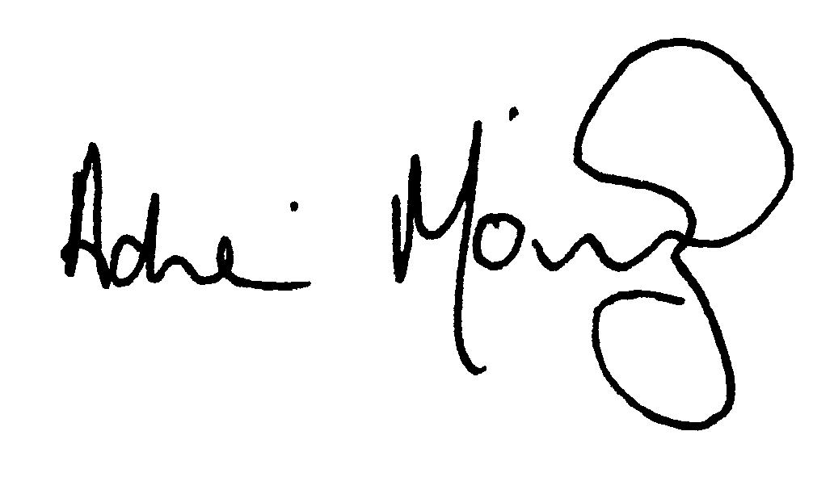  Name: Professor Adrian Mouritz  Title: Acting Deputy Head of School Aerospace and Aviation, School of Aerospace, Mechanical and Manufacturing Engineering  Date: 29 September 2014 | Approved: | Signature:  Name: Professor Aleksandar Subic  Title: Dean of Engineering and Head of School, School of Aerospace, Mechanical and Manufacturing Engineering  Date:

